

ITA0330-Mobile Computing

Name: T. Dharani Devi Reg no:192425036

Slot: D Course Name: Mobile Computing

Experiment 10: Comparison of Multiple Access Techniques
Aim: To create a visual representation showcasing the differences between various multiple access techniques.
Procedure:
- Open Figma and create a new design file.
- Create a frame for comparing multiple access techniques.
- Add separate sections for FDMA, TDMA, CDMA, and OFDMA.
- Draw diagrams showing how each technique shares communication resources.
- Label frequency channels, time slots, codes, and subcarriers.
- Add the advantages and applications of each technique.
- Use different colors and a comparison table to present the differences clearly.
Output:
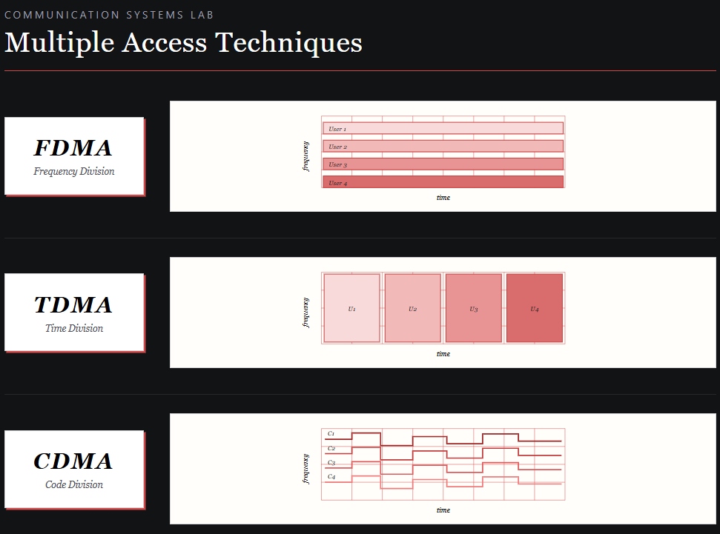
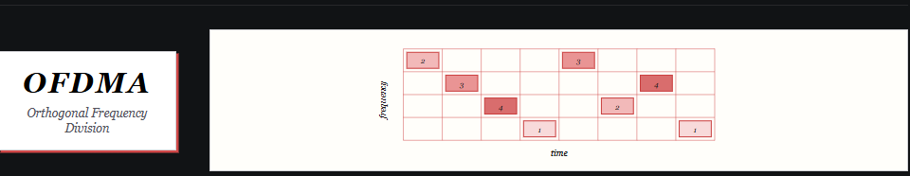
https://www.figma.com/make/NYfYH7KictiCfjS6o7lyDr/EXPERIMENT-10?t=q4ehJPQngmonsvrw-0
Result: Thus, a visual comparison of FDMA, TDMA, CDMA, and OFDMA was created successfully using Figma.

